# Connect to Drone

1. Disconnect internet and remove LAN Cable if any
2. Connect to Drone’s Wi-Fi
3. Use telnet or FTP
   1. <ftp://192.168.1.1:5551/>
   2. telnet 192.168.1.1
4. Open version.txt to see the drone’s firmware. It should be 1.3.3 to allow hacking of drone and communicating via serial.
5. If it is 1.3.3 then move to Enabling Serial Port, else first Downgrade the drone’s firmware

# Downgrade the drone’s firmware

This step only needs to be performed if the Drone’s firmware **IS NOT 1.3.3**

From PC (I used windows7)

1. Connect to the drones network (Wi-Fi) with the PC.

2. Telnet to the drone  
   telnet 192.168.1.1

Telnet looks like this when connected:

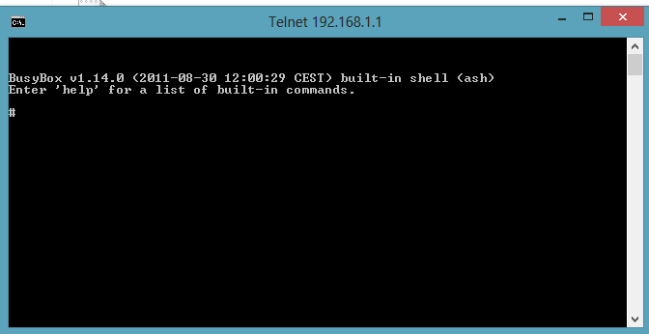

3. Create two version.txt in different catalogs.  
   Write the following in the telnet session to do that:

cat > /firmware/version.txt [enter]

0.0.0 [Enter] [Ctrl-D]

cat > /update/version.txt [enter]

0.0.0 [enter] [Ctrl-D]

[Enter] means press the "enter" key   
[Ctrl-D] means press the "Ctrl and the D" key

Explanation:   
/firmware/version.txt must be "lower" than the /update/version.txt  
/update/version.txt must have same number as the update file

4. Check that you got it right.

cat /firmware/version.txt [enter]

Should say: 0.0.0

cat /update/version.txt [enter]

Should say: 0.0.0

Disconnect from telnet

5. Upload ardrone_update.plf by simply typing <ftp://192.168.1.1:5551/> on Windows file explorer and copying the above file into the opened folder.

6. Disconnect the battery for a couple of seconds.

7. Connect the battery again and the update starts.  
    Don't disconnect until the LEDs are green, takes 2-3 minutes.

# Enabling Serial Port